Redcliffe Parish

Parish Profile

November 2023

***PARISH MISSION STATEMENT***

To individually and corporately offer worship to God, to spiritually nurture each parishioner, and witness to our local community.

***WHERE ARE WE***

**Northern Region:**

Bishop Jeremy Greaves

**Archdeaconry of Lilley:**

The Ven David Ruthven

**Deanery of Redcliffe:**

The Rev’d Avriel Green

**Redcliffe Parish:**

City of Moreton Bay, Suburbs of Redcliffe, Scarborough, Newport, Kippa-Ring, and Rothwell

Postcodes 4020, 4021 and 4022

Southern boundary is Macdonnell Road

**Churches:**

St Mary’s

93 Sutton Street, Redcliffe QLD 4020

St Anne’s

190-192 Mein Street (corner Warde St)

Scarborough QLD 4020

**Parish Office:**

The Stephen Jull Centre

97 Sutton Street, Redcliffe QLD 4020

Telephone: (07) 3284 2393

Email: [redang@westnet.com.au](mailto:redang@westnet.com.au)

Distance from Cathedral (no tolls)

31.8km to 38.4 kms.

Postal Address:

PO Box 439, Redcliffe QLD 4020

Opening Hours:

Wednesday 9am to 1pm

Tuesday & Thursday by appointment

**Rectory:**

91 Sutton Street, Redcliffe QLD 4020

**Facebook:** <https://www.facebook.com/Redcliffe.Anglican.Parish>

<https://www.facebook.com/profile.php?id=100067777238182> (St Anne’s Playgroup)

***CHURCHES & FACILITIES***

**St Mary’s** (seats 200) Dedicated 1898, Rebuilt and Dedicated 1959 Consecrated 1967

93 Sutton Street REDCLIFFE QLD 4020

Holy Communion Services on Sunday at 7.30am and on Wednesday at 9.30am.

Feast day for St Mary on Sunday before 15 August.

**St Anne’s** (Seats 80) Dedicated 1970 Consecrated 1976

190-192 Mein Street (corner Warde Street) SCARBOROUGH QLD 4020

Distance from St Mary’s = 4.7km.

Holy Communion Services on Sunday at 9.30am.

Feast day for St Anne on Sunday before 26 July.

Both churches are in reasonably good condition.

The Holy Communion service follows A Prayer Book for Australia (Second Order) and Together in Song. Readings are printed on a Pew Sheet which is given to worshippers. The Pew Sheet is also loaded onto the Parish Facebook site.

High Mass with incense is used on feast days and other special occasions including: Christmas Day, Australia Day service, Easter Day, Pentecost, Trinity Sunday, St Anne’s Day, St Mary’s Day, All Saints Day, and Christ the King.

St Mary’s has a stained-glass window from 1912 in memory of W.G.Hayes.

St Mary’s has a pipe organ built by John Compton Organ Co. London c.1959 and installed in 1963 from the showroom of W.H. Paling, Brisbane. St Anne’s organ was installed in 2018 and was funded by parishioner donations.

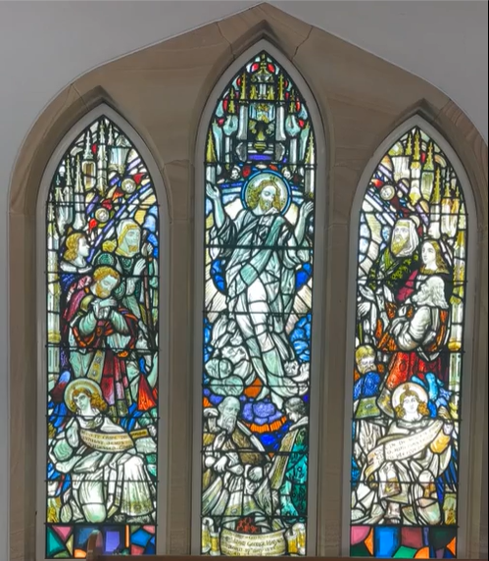 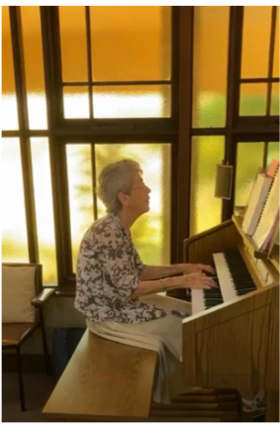

**St Mary’s Hall** was originally built at the Chermside Army Camp in 1941 and was moved to Sutton Street Redcliffe about 1946 behind the timber church facing south, then moved to face east about 1965 with kitchen extension, mostly located on 91 Sutton St land. Brick veneer added to the Hall in 1980s. The hall has been used for various short and long term rentals and is presently leased to a construction company that has recently commenced work on an apartment complex adjacent to the church.

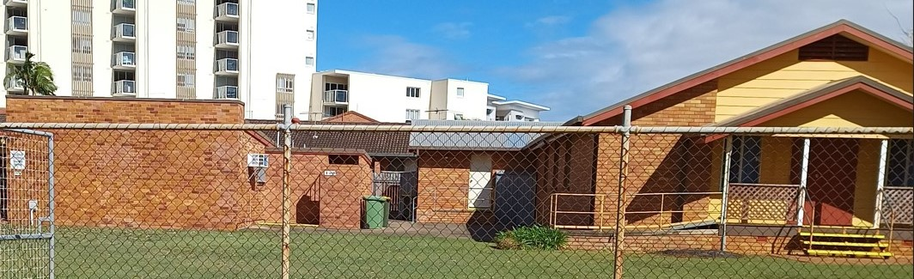

**Jull Centre** is a two-storey brick building opened by the Redcliffe Masonic Lodge in 1985 . It was purchased by the Parish in 2000. The building is named after Rev. Canon Jull, who was Rector in the parish from 1952 to 1977. The top floor houses the Parish Office and is in excellent condition. Ducted air conditioning was installed in 2020. The building has both internal and external stairs, the internal stairs being fitted with a chair lift. The ground floor has a kitchen, air-conditioned meeting area, one shared Male/Disabled toilet, and two female toilets. The ground floor meeting area is used for various parish meetings and activities, it is also available for hire.

**Rectory** is a single storey, 4BR brick building built in 1982 beside the church. A separate brick garage was also built in 1982 in the backyard. This served as the Parish Office until 2000 and purchase of the Jull Centre. The garage is now used as a large storage room and is in good condition. A brick toilet block with one male and one female toilet is also situated on the Rectory land, plus part of St Mary’s Hall (above).

**St Anne’s Hall, Scarborough**, a timber hall, opened in 1950, originally for the conduct of church services. It is used by the Parish for various meetings and activities, including Playgroup on Monday mornings (since 2007) and is also available to hire. Separate male and female toilets are located outside.

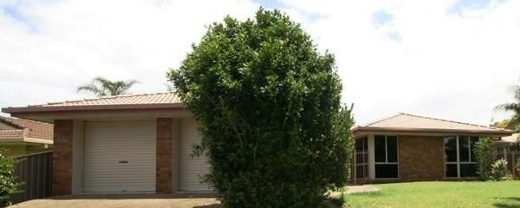

**Regency Street, Kippa-Ring**

The Parish owns an investment house that is currently rented out and is in good condition.

***A BRIEF PARISH HISTORY***

1882 – The Rev’d John Sutton gave to the church 43 perches of land in Sutton Street as a site for a future church building.

Rev’d Sutton was Rector of St John’s Pro-Cathedral in William Street Brisbane from 1869 to 1885. He retired to Redcliffe and built a home named Hurley House on the seafront. He commenced Anglican services at his home on 21 February 1886, and commenced a church building fund in March 1886.

1891 – Services began at the Redcliffe Provisional School and a small organ was loaned.

1897 – The Rev’d John Sutton passed away.

1898 – Money was loaned, and St Mary’s church was built. It was dedicated by The Right Rev’d William Webber, Bishop of Brisbane.

20 April 1948 – Redcliffe attained Parish status and the Rev’d Charles Gillman was appointed the first Rector of the parish.

1950 – St Anne’s Church at Scarborough was officially opened.

1952 -1977 – The Rev’d Alfred Stephen Jull served as the parish’s second Rector.

27 April 1958 – Foundation stone for the present St Mary’s church was laid by Archbishop Reginald Halse.

29 November 1959 – St Mary’s Church was completed and dedicated by Archbishop Reginald Halse. The former church was moved to Clontarf and renamed St Barnabas.

7 May 1967 – St Mary’s Church was consecrated by the Archbishop Philip Strong.

22 November 1970 – A new St Anne’s Church was dedicated by Archbishop Felix Arnott.

28 November 1976 – St Anne’s Church was consecrated by Archbishop Felix Arnott.

1977 – 1983 – The Rev’d John Thompson served as the parish’s third Rector.

1983 – 1996 – The Rev’d William Pearson served as the parish’s fourth Rector.

1996 – 2023 - The Rev’d Graheme Baldock served as the parish’s fifth Rector.

***PARISH GROUPS AND ACTIVITIES / COMMUNITY OUTREACH***

The Parish offers -

Meditation Group on Mondays.

Playgroup for parents and young children on Mondays at St Anne’s during school terms.

Bible Studies at St Anne’s on Wednesdays and at St Mary’s on Fridays.

Junior Church is held on the 4th Sunday of the month at St Anne’s.

Mothers’ Union meet on the 4th Wednesday of the month after the 9.30am Holy Communion service.

Cursillo members meet with Deception Bay church members in the neighbouring Freshwater parish.

St Mary’s Guild and St Anne’s Guild clean the two churches and arrange flowers for services. The Guilds also cater for funerals and other functions on request.

The Guilds hold street stalls at various times during the year selling jams, cakes, biscuits, and craft items to raise money for parish projects. An annual Christmas Fair is also held at St Mary’s.

The parish is also actively involved in several community groups and activities:

* Monthly Holy Communion services are held at BallyCara Retirement Village, Scarborough and Seabrae Manor Aged Care, Rothwell.
* The Redcliffe Samoan Methodist Church have worshipped at St Mary’s since 2000. Members of the Samoan community also assist with maintaining the church grounds.
* One parishioner is a volunteer chaplain at Redcliffe Hospital.
* There has been a longstanding tradition of parishioners providing Religious Instruction in state schools.

Refer Appendix 2 for information regarding our wider community.

***LAY LEADERSHIP***

Number of licensed lay assistants: 9

Do lay people read the lessons? Yes

Do lay people lead the intercessions? Yes

**In what ways do lay members of the parish take responsibility for aspects of the day-to-day administration of the parish?**

Lay members support the priest by carrying out roles of Wardens, Synod Representatives, Parish Nominators, Parish Councillors, Parish Treasurer and Secretary of Parish Council. Currently parish council meets monthly, on the 3rd Sunday of the month.

The parish office is staffed by a roster of volunteers. They assist with numerous administration tasks including the preparation, collation and uploading to Facebook of weekly pew bulletins, preparation of the weekly prayer list and intercessions, and preparation of an annual hymn and reading list. Furthermore, a three-monthly parish calendar is also formulated for planning purposes.

Parish rolls, records, and safety management documentation are appropriately maintained.

Rosters are also in place for liturgical assistants, servers, greeters, morning tea servers, counters and bankers, and church cleaners.

**In what other ways do lay people exercise ministry within the parish?**

Lay members assist with pastoral care, including taking Home Communions. As also noted above, one parishioner is a volunteer chaplain at Redcliffe Hospital.

***PARISH WEAKNESSES, STRENGTHS, AND OPPORTUNITIES***

It is clear that from the parish dashboard data (Appendix 1) that COVID-19 had a dramatic impact on parish attendance and the numbers have not yet rebounded.

The age profile of the parish is significantly higher than the surrounding community and even the Diocese, with 72% of parishioners being over 70, and virtually no one in the 18–40 year-old age bracket.

While there hasn't been an increase in the number of children over the past couple of years, the parish experienced the addition of five new adults in 2022. Furthermore, as noted above, the parish offers a playgroup and junior church at St Anne’s, reflecting ongoing efforts to engage with and support various age groups within the community.

Despite the decline in attendance, the finances of the parish remain robust, and the Parish is debt free. The main sources of income are from parishioner offerings, as well as investment property and church hall rentals. More detailed financial information is available upon request.

Although overall numbers are modest, there exists a dedicated core group within the parish who are committed and enthusiastic about fostering its growth and success.

The potential of this parish to connect with its local community and be a hub that holds it together is undeniable. St Mary’s church is situated amid several new apartment blocks and construction of a new housing development has recently commenced beside the church (99 Sutton Street, see below). The dynamic shifts in the surrounding community emphasize the crucial need for the parish to evolve in sync with these changes. A clear mission action plan needs to be developed that reconfigures the parish’s infrastructure and worship to meet the ever-changing needs of the community.

**Adjoining Brisbane Housing Company (BHC) Development - 99 Sutton Street**

The development by BHC will deliver 82 new homes (59 social and 23 affordable) for persons over 55. Each unit will have ample living space, one bedroom, and a multi-purpose room. There will be 66 carparks.

[Sutton-Street-fact-sheet-120723.pdf (bhcl.com.au)](https://bhcl.com.au/wp-content/uploads/2023/07/Sutton-Street-fact-sheet-120723.pdf)

<https://www.moretonbay.qld.gov.au/Services/Building-Development/DA-Tracker/9725981>

***WHAT WE ARE SEEING IN A NEW PRIEST***

The qualities we see as being important for our new priest is someone who:

* Has proven ministry experience, including outreach to younger generations.
* Has strong people skills, clear communication, and effective leadership.
* Is a strategic, forward thinker, who will work with the parish to develop a clear mission action plan for parish renewal and growth.
* Is keen to develop strategies to attract prospective parishioners yet is respectful of the traditions of the current congregations.
* Has managerial, administrative, and technological skills.
* Is a person of prayer, who seeks to be guided by the Holy Spirit and who preaches the gospel faithfully.
* Is vibrant, charismatic, with a good sense of humour.

**CONTACT INFORMATION**

If you would like to know more, please contact:

Joanne Rose

Personal Assistant

Bishop’s Office

P:   (07) 3835 2213

F:   (07) 3832 5030

E:   jrose@anglicanchurchsq.org.au

E:   bsecretary@anglicanchurchsq.org.au

Or

The Venerable David Ruthven

Archdeacon of Lilley

Ph (07) 3285 6333

**APPENDIX 1 – PARISH DASHBOARD DATA**

**APPENDIX 1 – PARISH DASHBOARD DATA**

**APPENDIX 2 – WIDER COMMUNITY INFORMATION**

**Population Census Data**

|  |  |  |
| --- | --- | --- |
| Area | Population | Est. People Identifying Anglican |
| Redcliffe | 10,460 | 1,497 |
| Scarborough – Newport | 15,257 | 2,084 |
| Kippa-Ring – Rothwell | 17,385 | 2,194 |
| Overall Total Parish Area | **43,102** | **5,775** |

Sourced from the 2021 Census data released by the Australian Bureau of Statistics in June 2022

**Hospitals and Aged Care/Retirement Homes**

There are 2 hospitals within our parish geographical area:

* Redcliffe Public Hospital, Redcliffe
* Peninsula Private Hospital, Kippa-Ring

There are a number of aged care homes and retirement villages within our parish geographical area, with the main facilities being:

* Azure Blue Retirement Village, Redcliffe
* BallyCara Aged Care, Scarborough (Service held
* Seabrae Manor Aged Care, Scarborough (Service held
* Beaumont Care, Kippa-Ring & Rothwell
* The Village Redcliffe Retirement Community, Rothwell

**Nearby Churches & Schools**

|  |  |  |
| --- | --- | --- |
| Area | Churches | Schools / Tertiary Education |
| Redcliffe | Redcliffe Uniting Church | Redcliffe State High School  Redcliffe Special School  TAFE Queensland Redcliffe Campus  University of the Third Age (U3A) Redcliffe |
| Scarborough – Newport |  | Scarborough State School  Australian Trade College North Brisbane  Southern Cross Catholic College,  Scarborough Campus |
| Kippa-Ring – Rothwell | Holy Cross Catholic Church, Kippa-Ring  Mueller Community Church, Rothwell  Lifepoint Church, Rothwell  Hope Centre, Rothwell | Kippa-Ring State School  Hercules Road State School  Southern Cross Catholic College,  Kippa-Ring Campus  Mueller College  Grace Lutheran College, Rothwell Campus |

There are other small churches within the Parish area.